

**المملكة العربية السعودية**

وزارة التعليم العالي

جامعة طيبة (39)

كلية علوم وهندسة الحاسب الآلي

**Kingdom of Saudi Arabia**

Ministry of Higher Education

Taibah University (039)

College of Computer Science and Engineering (CCSE)

**Database Systems: CS372 Section:M1**



**Games store by:**

* **Abdulrahman Wasel alrehile (4201495)**

**Supervised By**

**Dr. Bassam Al-Maghdawi**

**Contents**:

|  |  |
| --- | --- |
| **Section 1** | Write an overview of the problem mini-world (i.e. problem and solution) |
| **Section 2** | Subdivide the mini-world problem into Entities, Attributes, and Relationships, and draw a conceptual ER diagram for the chosen mini-world. |
| **Section 3** | Design a relational model by mapping the conceptual ERD to a logical relational schema. Highlight the mapping process steps in your design. |
| **Section 4** | make the tables and update the information |
| **Section 5** | Code |

**Abstract:**

The "Games Store" SQL program is a comprehensive database system designed to manage the operations of a game store.

* **Section 1:**
* **Problem Overview:**

The game store aims to manage its inventory, customer transactions. The store needs to keep track of games, customers, orders, products, payments, developers, tracking details, product feedback, and promotional offers. The goal is to create a robust database system that allows for efficient management and retrieval of information related to these entities.

* **Solution:**

The proposed solution involves creating and maintaining a relational database that efficiently stores and retrieves information about games, customers, orders, products, payments, developers, tracking details, product feedback, and offers. The system should be capable of:

**Handling Payments:** Recording payment details, including total amounts, payment dates, methods, and payment statuses.

**Tracking Orders:** Managing tracking details to monitor the delivery status of orders.

**Developer Information:** Storing details about game developers, including their names, websites, and contact email addresses.

**Collecting Feedback:** Gathering and storing customer feedback on products, including review dates, review IDs, and ratings.

**Offering Promotions:** Implementing a system for providing promotional offers to customers, including offer IDs, promo codes, and percentage discounts.

* **Section 2:**
* **Entities:**
* **Game:**

The main entity representing each individual game in the store. Attributes: game_id (Primary Key), games_name, genre, max_no_players, platform_name.

* **Customer:**

Represents the people who visit the store and purchase games. Attributes: customer_id (Primary Key), frist_name, last_name , email, phone, city, street.

* **Order:**

Represents a transaction where a customer purchases one or more games. Attributes: order_id (Primary Key), order_date, customer_id, game_id, order_status.

* **Product**:

that could represent various types of products in the store.. Attributes: Product_id (Primary Key), description, product_name, price.

* **Payment**:

Represents the companies or individuals who develop the games. Attributes: customer_id, order_id , total_amount, payment_date, payment_method, Status.

* **Developer**:

Represents the companies or individuals who develop the games. Attributes: developer_name, website, contactemail.

* **Tracking_detail:**

Represents the companies or individuals who develop the games. Attributes: tracking_no (Primary Key), courier_name.

* **product_feedback:**

Represents the companies or individuals who develop the games. Attributes: Review_Date, Review_ID,Rating.

* **offer:**

Represents the companies or individuals who develop the games. Attributes: Offer_ID, Promo_Code, Percentage_Discount.

* **Relationships**:
* **Game-Developer Relationship:**

One-to-Many relationship indicating that a game is Managed By one developer, but a developer can have multiple games. Game (1) -----< Developer (N).

* **Order-Customer Relationship:**

One-to-Many relationship indicating that a customer can make multiple orders, but each order is placed by one customer. Order (1) -----< Customer (N).

* **Product- Games Relationship:**

Many -to-Many relationship indicating that a Product has multiple Games. **Product** (N) -----< **Games** (M).

* **Product- product_feedback Relationship:**

One -to-Many relationship indicating that a Product has one product_feedback. **Product** (1) -----< product_feedback (N).

* **Order- Product Relationship:**

One-to-Many relationship indicating that a Order contains multiple Product. Order (1) -----< **Product** (N)

* **Order- Tracking Detail Relationship:**

One-to- One relationship indicating that a Order has multiple Tracking Detail. Order (1) -----< **Product** (1)

* **Customer - product_feedback Relationship:**

One-to-Many relationship indicating that a customer can gives multiple product_feedback. Customer (1) -----< product_feedback (N).

* **Customer - product Relationship:**

One-to-Many relationship indicating that a customer can purchase multiple product . Customer (1) -----< product(N).

* **Customer – Payment Relationship:**

One-to-Many relationship indicating that a customer can Create multiple Payment. Customer (1) -----< Payment (N).

* **Payment – offer Relationship:**

One-to-Many relationship indicating that a Paymentcan applied to multiple offer. Payment(N) -----< offer(1).

* **Order- Payment Relationship:**

One-to- One relationship indicating that a Order make one Payment. Order (1) -----< Payment (1)

* **Conceptual ER diagram:**

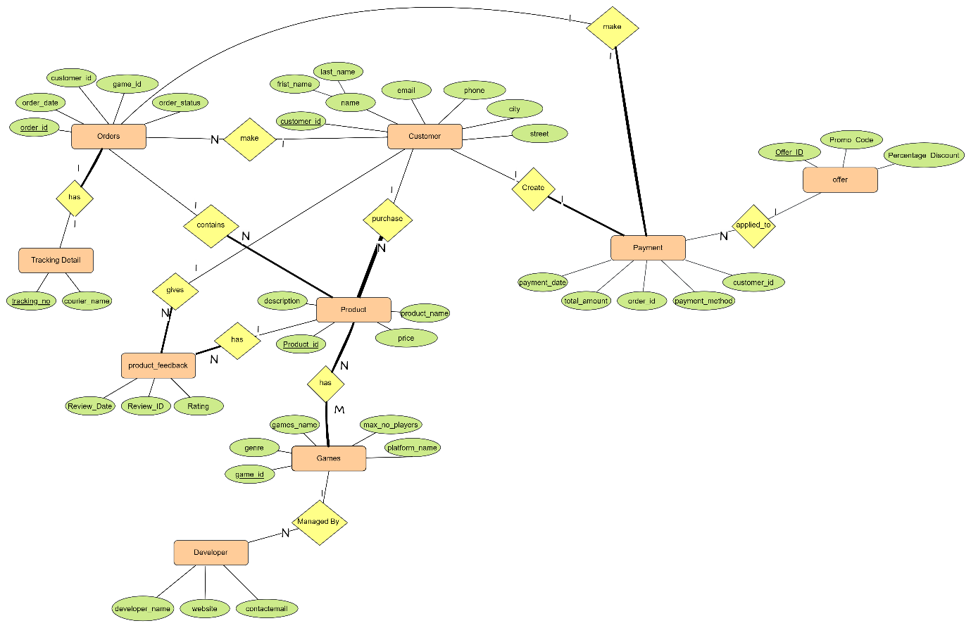

* **Section 3:**
* **Relational mode:**

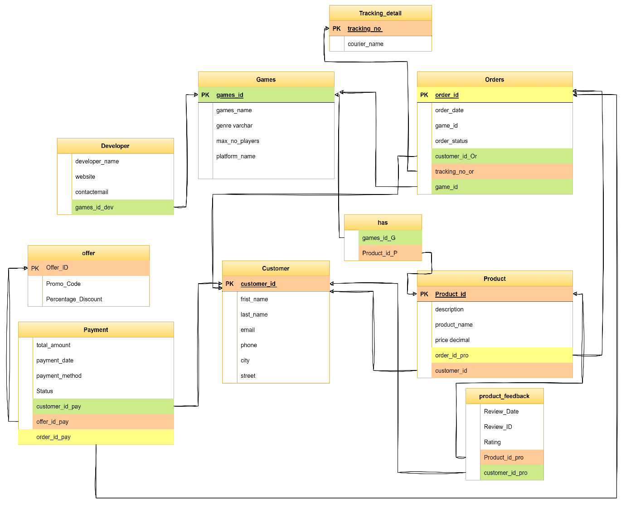

* **Section 4:**

**Table:** Current spreadsheet that game store is using to keep track of its sales.

* **Game:**

صورة تحتوي على نص, لقطة شاشة, الخط, خط

تم إنشاء الوصف تلقائياً

* صورة تحتوي على نص, لقطة شاشة, خط, الخط

  تم إنشاء الوصف تلقائياً**Customer:**
* **Order:**

صورة تحتوي على نص, لقطة شاشة, الخط, خط

تم إنشاء الوصف تلقائياً

* **Product:**



* **Payment:**



* **Offer:**



* **Developer:**



* **Tracking_detail:**



* **product_feedback:**



* **Section 5:**
* **Code:**

CREATE TABLE Games

(

games_id Integer PRIMARY KEY,

games_name varchar(255),

genre varchar(255),

max_no_players Integer,

platform_name VARCHAR(20) NOT NULL,

);

create table Customer

(

customer_id int not null primary key,

frist_name varchar(15) not null,

last_name varchar(15) not null,

email varchar(50) not null,

phone varchar(30) unique,

city varchar(30) not null,

street varchar(30) not null,

);

create table Orders

(

order_id int not null primary key,

order_date date,

customer_id int,

game_id Integer,

order_status varchar(255),

constraint Customer_Order_fk foreign key(customer_id)

references Customer(customer_id),

constraint Game_Orders_fk foreign key(game_id) references Games(games_id),

);

CREATE TABLE Product

(

Product_id integer PRIMARY KEY,

dess varchar(150),

product_name varchar(255),

price decimal(5 ,2 ),check(price between 20 and 400),

constraint games_Product_fk foreign key(Product_id)references Games(games_id),

);

CREATE TABLE Payment (

customer_id int not null ,

order_id int not null,

total_amount DECIMAL(10, 2),

payment_date date,

payment_method VARCHAR(50),

Status VARCHAR(50),

constraint Customer_Pay_fk foreign key(customer_id)

references Customer(customer_id),

constraint Orders_Payment_fk foreign key(order_id )

references Orders(order_id ),

);

CREATE TABLE offer (

Offer_ID INT ,

Promo_Code VARCHAR(50),

Percentage_Discount VARCHAR(50),

);

CREATE TABLE Developer (

developer_name VARCHAR(100),

website VARCHAR(255),

contactemail VARCHAR(255)

);

CREATE TABLE Tracking_detail (

tracking_no INT PRIMARY KEY,

courier_name VARCHAR(50),

);

CREATE TABLE product_feedback (

Review_Date date,

Review_ID int,

Rating decimal(2,1),

constraint Customer_product_feedback_fk foreign key(Review_ID)

references Customer(customer_id),

);

insert into Games(games_id,games_name,genre,max_no_players,platform_name)

values(1,'dead by daylight','Survival horror',5,'Windows')

,(2,'valorant ','shooter',10,'Windows')

,(3,'The Last of Us','Action-adventure',2,'PlayStation');

select * from Games;

insert into Customer(customer_id,frist_name,last_name,email,phone,city,street)

values(4201495,'abdulrahman','alrehile','abd@gmail.com',0566276214,'madinahh','omar'),

(5466,'omran','alharbi','omran@gmail.com',0589276761,'jeddah','abo baker');

select *from Customer;

insert into Orders(order_id,order_date,customer_id,game_id,order_status)

values(12,2002-11-04,4201495,1,'Order Placed'),

(24,2005-7-11,5466,3,'Order Dispatched');

select *from Orders;

INSERT INTO Product(Product_id, dess, product_name, price)

VALUES

(3, 'The Last of Us is a 2013 action-adventure game developed by Naughty Dog and published by Sony Computer Entertainment.', 'The Last of Us', 20.99);

select *from Product;

insert into Payment(customer_id,order_id,total_amount,payment_date,payment_method,Status)

values(4201495,12,$9.99,'2023-11-05','paybal','Completed');

select *from Payment;

INSERT INTO offer(Offer_ID, Promo_Code, Percentage_Discount)

VALUES

(95, 'ksa', 15);

select *from offer;

insert into Developer(developer_name,website,contactemail)

values(null,null,null);

select *from Developer;

insert into Tracking_detail(tracking_no,courier_name)

values(2214,null);

select *from Tracking_detail;

INSERT INTO product_feedback(Review_Date, Review_ID, Rating)

VALUES

('2022-09-01', 4201495, 4.4);

select *from product_feedback;